**SUMMARY**

**1. INTRODUCTION (Sarah & Paula)** **3**

**2. CURRENT FUNCTIONAL PROCEDURES (Aline)** **5**

**3. PROJECT OBJECTIVES (Darwin)** **6**

**4. FEASIBILITY STUDY (Aline)** **7**

**4.1 LOW-COST ALTERNATIVE (Darwin)** **8**

**4.1.1 Assumptions and Constraints (Darwin)** **9**

**4.1.2 Analysis and Methodology (Darwin)** **9**

***4.3.2.1.1 Use case diagram – Physical Store System*** ***10***

**4.1.3 Feasibility Study** **11**

***4.1.3.1 Technical Feasibility (Darwin)*** ***11***

***4.1.3.2 Operational Feasibility (Sarah)*** ***11***

***4.1.3.3 Economic Feasibility (Paula)*** ***12***

***4.1.3.4 Scheduling Feasibility (Aline)*** ***14***

**4.2 MID-RANGE ALTERNATIVE (Darwin)** **15**

**4.2.1 Assumptions and Constraints (Darwin)** **15**

**4.2.2 Analysis and Methodology. (Darwin)** **16**

***4.2.2.1 Wireframe Design*** ***16***

**4.2.3 Feasibility Study** **17**

***4.2.3.1 Technical Feasibility (Darwin)*** ***17***

***4.2.3.2 Operational Feasibility (Sarah)*** ***18***

***4.2.3.3 Economic Feasibility (Paula)*** ***19***

***4.2.3.4 Scheduling Feasibility (Aline)*** ***20***

**4.3 HIGH-END ALTERNATIVE (Darwin)** **21**

**4.3.1 Assumptions and Constraints (Darwin)** **22**

**4.3.2 Analysis and Methodology (Darwin)** **23**

***4.3.2.1.2 Object- Oriented Data Model Design*** ***24***

***4.3.2.2.1 Use case diagram– Online Store*** ***25***

**4.3.3 Feasibility Study** **25**

***4.3.3.1 Technical Feasibility (Darwin)*** ***25***

***4.3.3.2 Operational Feasibility (Sarah)*** ***27***

***4.3.3.3 Economic Feasibility (Paula)*** ***27***

***4.3.3.4 Scheduling Feasibility (Aline)*** ***29***

**5. RECOMMENDATION (Aline & Paula)** **31**

**6. FINAL CONSIDERATIONS (Aline)** **32**

**7. BIBLIOGRAPHY** **33**

**APPENDICES** **34**

# 1. INTRODUCTION (Sarah & Paula)

Living in a digital/globalized world affects everybody’s life in many different ways. Technology is needed nowadays for even simple tasks like calling, starting your car and buying groceries at the supermarket. But technology not only affected people’s life, it also affected organizations in ways that changed completely how they deal with consumers and other businesses. The use of internet is the most necessary item to live in such digitalized world.

Internet has been interconnecting people and businesses since 1990s, when it emerged. To be global from a company’s perspective means that everybody can reach its products from anywhere and anytime. But on the other hand its advent also brought a new way of doing business and a new way of competing with other businesses.

With the advent of the internet, new forms of goods, services and delivery channels have raised bringing up the E-Business, which is a different way of doing business. Nowadays, the physical presence of a firm in the market is not mandatory; once their goods can be available online. Janita and Chong (2013) define E-Business as the process of exchanging, buying and selling through computer networks involving internet. E-Business is considered to be an innovation that thoroughly changed the traditional way of doing business (Bordonaba-Juste, Lucia Palacios and Polo Redondo, 2012).

These two different ways of doing business are simultaneously in use nowadays and each one of them has its features and its issues. However, the transition from physical shop to digital shop has not yet reached some traditional shops. Having said that, it is important to mention the importance of doing a detailed feasibility study analysing whether is worth the changing.

According to Maracas and O’Brien (2013), feasibility study is a preliminary study where important aspects of the project such as resource requirements, costs, benefits, viability, etc are determined and taken into consideration before a decision is made for whether adapting the current system or changing completely to a new system. This study is presented in a written format which includes preliminary specifications and a developmental plan for a proposed business application. If the recommendations are approved by the management/owner, the development process takes place.

Conducting a feasibility study has the advantage of giving advance warning about where the project has more chances of failure or whether methods or instruments are inappropriate or unsuitable. Those studies may also identify potential practical problems in the following project implementation (Van Teijlingen and Hundley, 2001).

Evaluate alternative system solutions and presenting the most suitable business application for development is the main goal of the feasibility study which can be evaluated in five major categories (Maracas and O’Brien, 2013). The feasibility studies consider as main aspects: technical feasibility, operational feasibility, economic feasibility, schedule feasibility, legal and political feasibility.

# 2. CURRENT FUNCTIONAL PROCEDURES (Aline)

The Vintage Shop is a small business specialized in selling second-hand entertainment items such as: movie DVDs, music CDs and Vinyl Records. All the transactions of the shop are completed over the counter and all the documentation related to those transactions a d customers are archived manually.

In order to make a purchase, the customer presents cash to the shop assistant and the transaction is carried out based on a two-part voucher. The customer signs the voucher and keeps one copy, while the assistant retains the other copy of the voucher on the till.

At the end of each day the collected vouchers are sent to the Bookkeeper, responsible for filing them. All the records concerned to the transactions are kept for, at least, three years.

As previously stated, everything in the Vintage Shop is done manually: from the stock supply to the processes and also management of transactions and information, which generates a high demand of paper work requiring an urgent update in the current system.

There are a few constraints associated to the current functional procedures performed in the shop. Among them, it is possible to list the demand of numerous hours of paperwork and that the security related to the costumer’s information in not highly secured or easily accessed. The archives do not have a backup which is also something relevant in this context.

In order to increase the performance of the shop, Alex Davis (owner of the Vintage Shop) is looking for ways to optimize the business by implementing a computerized system.

The current model of the Vintage Shop is old fashioned, it does not require any type of technology such as hardware, software or network connection, and all the daily transactions are made manually. This technical assessment will not address any changes to the current system, and all the daily routine will sticky to the existing model of business, no technology will be attached.

# 3. PROJECT OBJECTIVES (Darwin)

This feasibility study has as main objective to assess three distinctly computerized systems to be implemented in a small business in town to support all the routine transactions, besides that, an online presence of the company is also required, which also allows customers and suppliers to perform transactions.

The study will indicate which system fits the needs of the business covering all the requirements established. Considering the physical store the system will be able to perform daily transactions, such as payments, printing receipts, vouchers, record control and stock supply. In addition, the system allows the clerk using specific technology to automate procedures, increasing productivity and reducing human error.

The online store, available 24 hours, will also be implemented to meet of the store goals, which allows the customer to register online, browse through the online catalog available and perform purchases’ The online shop also enables them to make payments via debit or credit cards. However, the delivery will be kept strictly physical. Moreover, the online presence will permit suppliers to perform payment transactions.

The current system is strictly manual, as stated previously, and all interactions with customers are in person. This sort of store still shows many advantages, once is known that some customers still prefer visiting physical stores, dealing directly with the vendor, holding, trying on or touching vinyl and CDs before buying them. Also, handling issues or doubts regarding the products directly with the vendor might be considered an advantage. The same criteria applies to the sense of security of knowing that the product, in fact, exists.

# 4. FEASIBILITY STUDY (Aline)

Feasibility study is, as the name suggests, an analysis and evaluation of the ability to complete successfully a project taking into consideration the most relevant factors. It is a study of a specific project with the purpose to determine the viability of an alteration in the system or general improvement.

In other words, the referred study seeks to identify the scheduling feasibility of the project and if it is technically, economically, legally and operationally feasible, determining positive and negative outcomes and, consequently, preventing the investment of a considerable amount of money into a project that will not be financially viable.

As previously mentioned, there are five main areas to be evaluated while developing a Feasibility Project and they will be described in detail below.

* Technical Feasibility - this assessment focuses on the available technical resources, like: engineering and architectural requirements, infrastructure, specific technology and equipment. It is also convenient in order to determine if the staff are capable of working with the new implemented system.
* Operational Feasibility - this assessment is mandatory in order to identify how well the project will be applied after the most suitable solution is chosen. It analyses the requirements for the system maintenance and personnel (for operation, support, maintenance and ongoing training).
* Economic Feasibility - this assessment analyses the required financial resources demanded for the project and financial benefits of the project implementation. It also considers the return of investment and time of payback.
* Scheduling Feasibility - this assessment is considered the most important in relation to the success of the project, and it is due to the fact that it is in this study that the time demanded for the implementation of the project is estimated. It basically traces the deadline for the strategies, plans and processes to be implemented in an achievable perspective.
* Legal Feasibility - this assessment consists on the research of legal issues and policies that may conflict with the interests of the project. This study requires the knowledge of certain laws, data protection acts, social media legal aspects and considers the specific location where the business is taking place, and once the legal aspects might change depending on that.

Taking into consideration the aspects previously described that are studied in a feasibility project, allows us to say that it also helps the companies to identify logistical problems and develop marketing strategies and negotiate with investors.

A feasibility study report also offer multiple possibilities of solutions such as maintain the actual scenario, amend the current system or the use of a new technology. The advantages and disadvantages of the possible solutions must be carefully studied as also the alternative of not changing the current system. Different processes and levels/types of computerisation are mandatory aspects to be evaluated when proposing new possible solutions. According to these parameters, this project aims to come up with three different solutions: the first one would be computerize the current system of the Vintage Shop but keep just the physical store; the second solution presents some important modernization aspects that would help the owner dealing with the paperwork and offering other payment mechanisms and a simple website to improve the Vintage Shop’s visibility with the customers, where the customers can browse through the page and the products catalog; the third solution demands more investment but it is also more comprehensive once it would open the possibility of online presence for the shop where the customers could buy the products. The three studied solutions will be properly addressed as follows.

## **4.1 LOW-COST ALTERNATIVE (Darwin)**

Considering the manager’s requirements, this first assessment will provide a brief study of an electronic point of sale system (EPoS system) that will be installed in the checkout counter allowing the staff to perform daily transactions and support the sales report. EPoS system comprise of a computer hardware, peripherals and software perfectly suited to the business needs, also it offers a wide variety of invaluable information on their demographic. Moreover, the computerized system helps the business by tracking everything from the inventory cycle to customer spendings. The EPoS proposed for this store must provide certain obligatory peripherals to offer a variety of benefits such as: chip and pin card machines, till system, cash drawers and a barcode reader. Those peripherals will reduce the human error and provide an accurate price of the goods, besides increasing significantly the speeding of tasks.

### **4.1.1 Assumptions and Constraints (Darwin)**

The current business model does not perform any transaction through any type of computerized devices, they are exclusively manual. In order to increase the productivity the new EPoS system installed in the counter might provide a series of benefits as previously addressed. However, some constraints might interfere in the system performance. The purchased system is not an open source system, thus it might not fit all needs of the shop, and some features might be not presented in the system. And in case of flaws, the system supplier must be contacted for support. Moreover, the supplier must provide fully training to the staff regarding the system usage. So, the system implementation might be suffer a direct changeover, considering that the shop has no system currently installed. Once the old system stops being used and the new becomes live. It is the cheapest, quickest and easiest form system changeover, however, very risky as long as the system might not meet the company needs, consequently becoming inefficient.

### 

### **4.1.2 Analysis and Methodology (Darwin)**

Primarily, it is important to gather information necessary for the system before buying it. Considering exclusively the off-the-shelf system in this section, the study must establish the pre-requirements for the future system, one which is able to perform daily transactions through the counter. A simple purchase from now on must be complete through the system, customer might choose payment type, cash, debit or credit card, and an inventory system will be attached to the system in order to keep track of product’s availability. Customer may also choose register themselves for future purchases.

System requirements:

* Complete daily activities;
* Scan items using a barcode;
* Register, update, and delete employees;
* Register, update, and delete products;
* Register, update, and delete customers;
* Register, update, and delete suppliers;
* Calculate taxes;
* Generate purchases orders;
* Print receipts;
* Allow manager to go over records;
* Keep track of inventory level;

In order to better represent all the information regarding the system above a use case diagram is precisely designed below following the Object-Oriented Models.

#### **4.3.2.1.1 Use case diagram – Physical Store System**

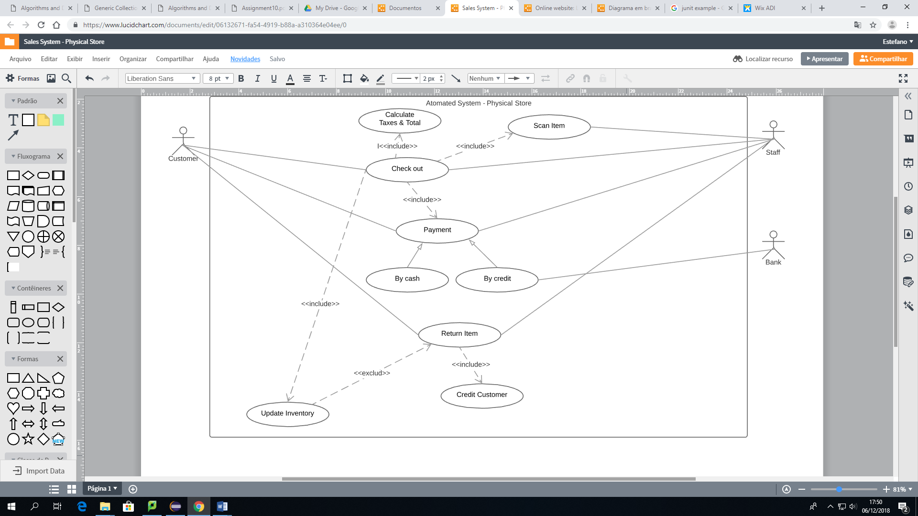

### **4.1.3 Feasibility Study**

#### **4.1.3.1 Technical Feasibility (Darwin)**

The solution proposed in this first assessment requires only a few changes in the current system, uniquely the store will have an EPoS system installed over the counter. This solution offers a variety of advantages for the store. It facilitates transactions, allows customer to choose among a sort of available payment methods, control stock supply, and keep track of the daily sales. It is the easiest solution to be implemented, due to the fact that the system comes embedded with the hardware, it is not necessary to purchase them separately, which could cause incompatibility between the system and hardware acquired. However, the support must be made by the supplier, whose has total access to the system.

Currently, the market offers a diversity in types of EPoS that fit to different physical commerces. In this case, the embedded system is available and the technology required can be purchased through different suppliers, and only takes a few days to be implemented. All the technical expertise is provided by the supplier, including the necessary training about how to use and get the best out of the system tools.

#### **4.1.3.2 Operational Feasibility (Sarah)**

As previously mentioned on topic 4.1, the idea of this study is improving the current system with the presence of a computerized system within the physical shop. Thus, when the performance is analysed whether this proposed system will provide adequate throughput and response time, it is possible to realise that the capability/speed/time dealt with during each transaction in store will be considerably increased, due to the use of a barcode scanner and the EPoS which provides faster information exchange and reports.

Analysing the information and the services provided by the proposed system, there will be an improvement regarding to accuracy and reliability of the information and as well as its relevance, timely, usability and flexibility once the EPoS fastly provides up to date inventory control, invoicing and receiving, interfacing with accounting, accounts payable and receivables etc.

Once more, the barcode scanner acts as a facilitator decreasing the human failures such as wrong input, difficulty of reading due to bad/wrong handwriting, delay in updating information within the store. Also, when examining its control against fraud and security of data and information it is possible to conclude that the current system it is not appropriate once the receipts are kept in store which facilitates the access of the information by anyone who should or should not have access to it. With the new proposed system, there is also the tender of using the Cloud as a server in order to keep it safe against fraud.

An efficiency analysis whether the current system makes maximum use of its available resources proves how inefficient the system is by contributing to lower levels of staff productivity. As mentioned before, a computerized system will increase the speed of transactions and activities, allowing the staff to do multiple activities and consequently increasing productivity. In addition, having boxes to store manually data and files is not environmentally-friendly and this could put the company’s documentation at risk in the case of a fire as there would be no back up. Thus, the use of the cloud as a server will extinguish this possibility.

For this first proposed software there will be the necessity of training the staff and the manager/owner on the EPoS in order to guarantee the above positive results. The operation of the system requires the access of internet, while support and maintenance can be made by the software seller once it will be obtained of the shelf. Information regarding to prices of each product, peripherals etc will be explored in the next section which is the Economic feasibility study.

#### **4.1.3.3 Economic Feasibility (Paula)**

The computerized system proposed in this project for the Vinyl shop intends to optimize the purchasing within the store. Therefore, it is recommended the acquisition of an EPoS bundle, which consists of a display, cash drawer, receipt printer and card machine. Also, it is necessary to acquire the software that will run the system and a barcode-reader to integrate the system and make it even more reliable. A broadband connection is also made necessary in this context, once software updates are released periodically, such as an initial training for the staff to properly adapt to the new system. For the training it is considered four sessions of thirty minutes each which is supposed to be enough for the staff to learn all the features of the new system as a whole.

The tangible costs were made taking into consideration three different sources and the average is shown in the table below. Discerning between development costs and operational costs. In addition to all the investments previously listed, an additional cost was considered during the operational phase, which is the thermal paper rolls for the receipt printer. There are no rolls to be considered for the card machine once the one chosen for this system does not require printing receipts, it sends it online as email or through text message instead.

| **Type of cost** | **Phase** | **Item/Service** | **Cost (average)** |
| --- | --- | --- | --- |
| **Tangible** | **Development** | Scanner (barcode-reader) | € 52.31 |
| EPOS bundle + software | € 1,338.00 |
| Training | € 367.31 |
| **Total development costs** | **€ 1,757.61** |
| **Operating** | Broadband (240 Mb - monthly) | € 38.17 |
| Rolls for receipt printer | € 1.00 |
| Rolls for card machine | € - |
| **Total operating costs** | **€ 39.16** |
| **Total tangible costs** | | **€ 1,796.78** |

As part of the economic feasibility analysis it is necessary to identify the benefits (tangible and intangible) that the proposed software is going to offer. As tangible benefits we can list fewer processing errors, once it will be all computerized there will be a decrease in errors due to wrong input or to difficulty of reading due to bad/wrong handwriting. Also, reduced data loss as all the data is going to be digitally stored within the system instead of vouchers kept in the till. The throughput and response time will increase as capability/speed/time dealt with during each transaction in store is going to increase and be faster. The sales might increase once more payment options will be available, instead of cash only, and the expenses will decrease once there will be no paperwork, therefore no need to pay a bookkeeper to keep the transaction registers.

As intangible benefits the improve in the customer service, the improve on the employee morale and a better decision making can be listed, once the computerized system will help to deal with the daily transactions in an optimized way, avoiding mistakes and reminding the staff of possible offers they can present to the customer.

| **Benefits** | |
| --- | --- |
| **Tangible** | **Intangible** |
| Fewer processing errors | Improved customer service |
| Increased throughput |
| Decrease time of each operation | Better decision making |
| Increase sales |
| Reduced expenses | Improved employee morale |
| Reduced data losses |

#### **4.1.3.4 Scheduling Feasibility (Aline)**

The Scheduling Feasibility of the Low-Cost alternative is, as expected, the most simple. Considering that the software to be installed in the till of the shop will be acquired off the shelf. No purpose in designing it once there are loads of offers in the market that will attend the requirements made by the owner of the Vinyl Shop.

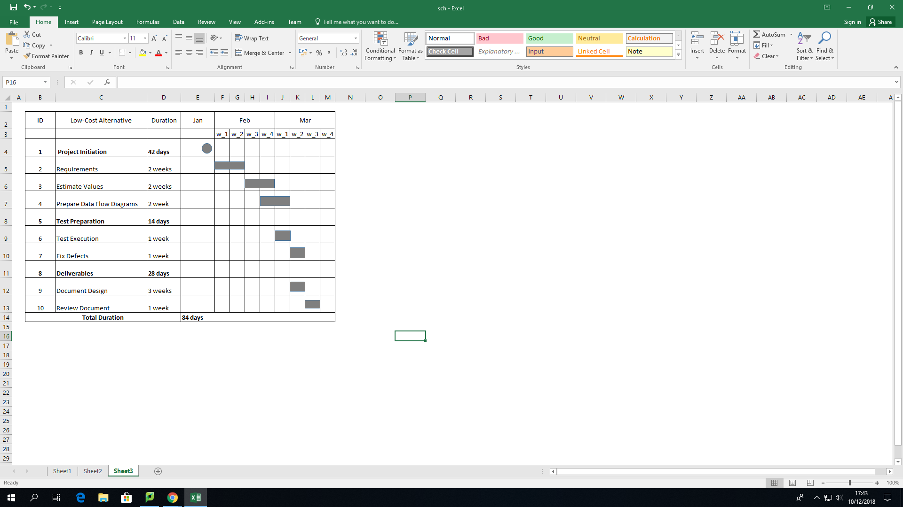

## **4.2 MID-RANGE ALTERNATIVE (Darwin)**

The second assessment will satisfy the company needs using an off-the-shelf solution in the presence store and a tailored online website. The physical store will still remain with the electronic point of sales system installed, no changes will be made in this aspect. Thus, this chapter will cover strictly the online web information store developed as mid-range-alternative. The online website will be brought to life with a singular function: working as a catalog for customers. Customers will be able to browse through the website and check out products on sale in the physical store, they also can find out more about the store history, contact information and location.

### 

### **4.2.1 Assumptions and Constraints (Darwin)**

The website requires certain technical capacity to be developed, so the owner must contract someone to be responsible for the maintenance of the website and to keep it up to date. It might result in some extra cost, however the system that will be utilised to develop the website might bring down the costs again. The website is strictly developed to work as a catalog and marketing channel, ensuring online presence and seeking for more visibility to the store brand.

### **4.2.2 Analysis and Methodology. (Darwin)**

In this section only additional system proposed, the website, will be described. In order to represent the designed system a wireframe and site map will be presented to describe the web page functionalities.

#### **4.2.2.1 Wireframe Design**

The wireframe represents the layout used to develop a website, in this case, on the head of page is displayed the logo, home, about us gallery, contact and the box search. Each icons have your particularities to make the user experience easily and friendly.

* **Home** **page**: displays a full image of the store, the business story, opening hours, contact, directions and social network such as Facebook and Instagram.
* **About** **us**: this section details the story of business since it was opened.
* **Inventory**: displays all the products on sale in the physical store in catalog format, underneath each image there is a brief description of the product.
* **Contact**: it is a link between the contacts in the home page, it works like an anchor that connect the contact link to the end of the page. In this section, information about location, contact and social networks are available to customer.

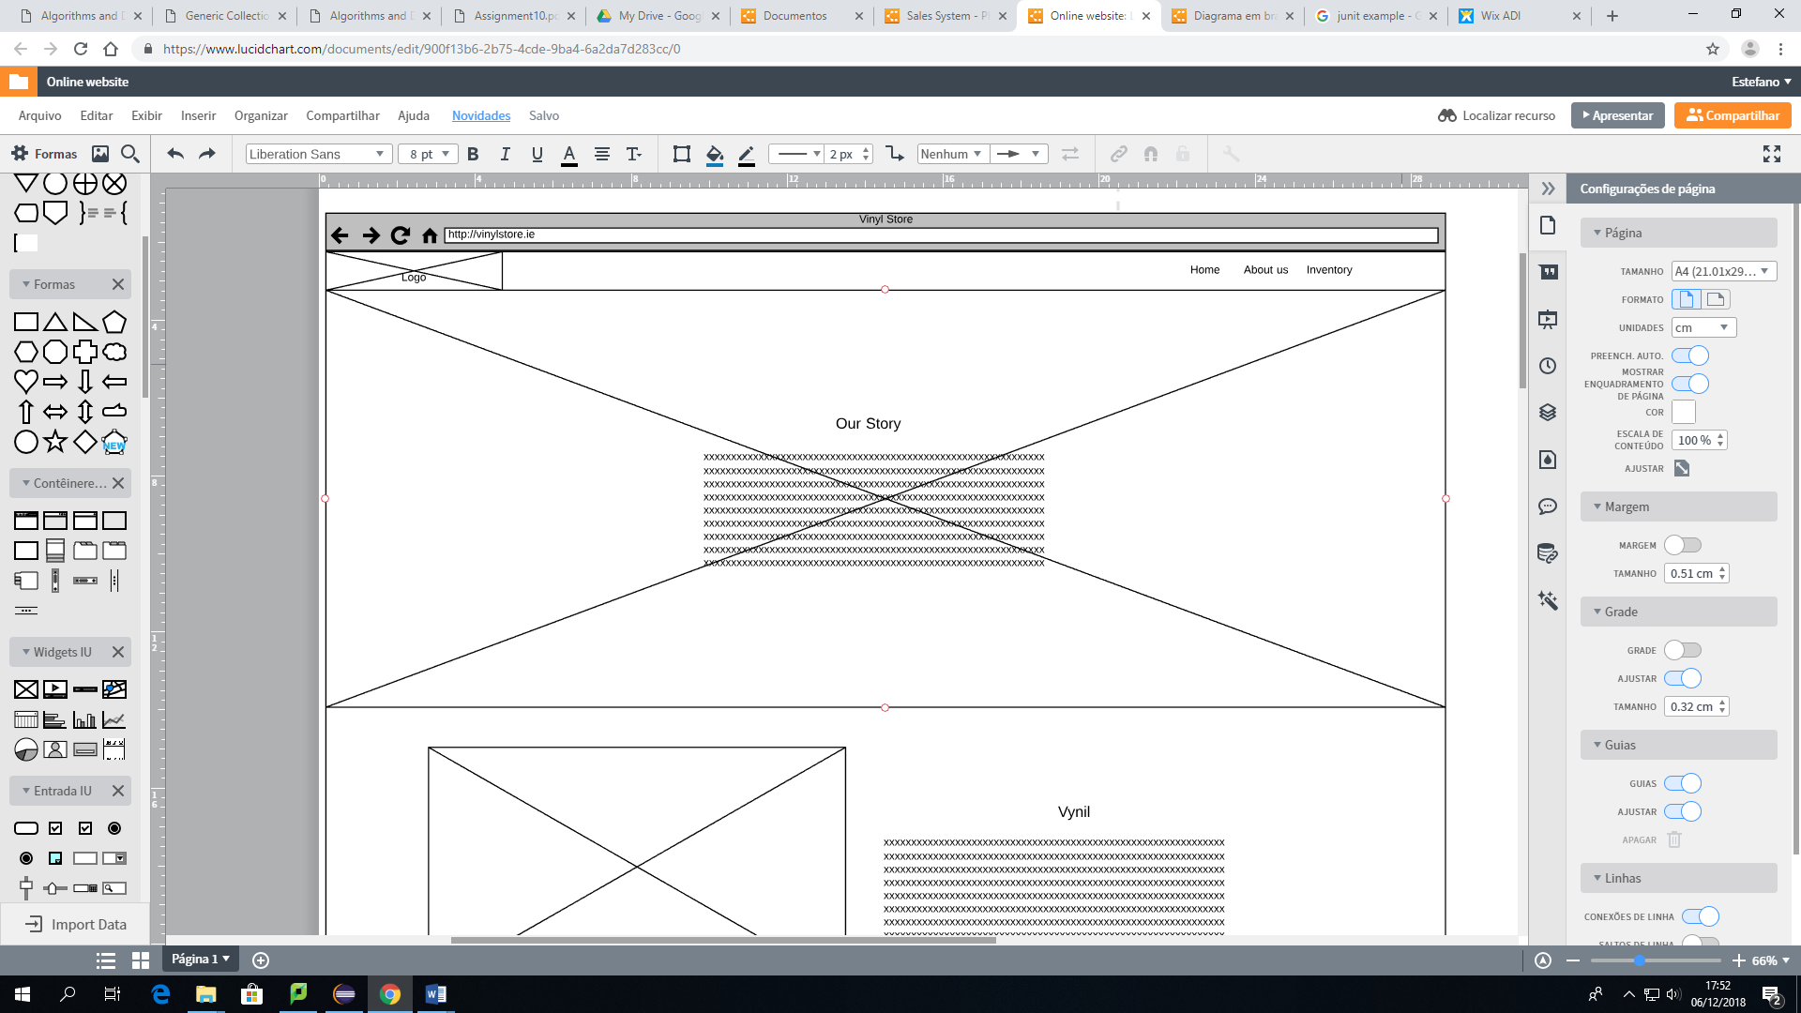

### **4.2.3 Feasibility Study**

#### **4.2.3.1 Technical Feasibility (Darwin)**

This second technical feasibility will be strictly dedicated to the website, considering that previous technical assessment described approaches the physical presence of the system. As a mid-range solution it also demands a bit of technical knowledge regarding to the website. This sort of product offers visibility of the online store and demands extra support to maintain the website up to date and on.

For this stage, company has improving its business searching for better solutions bringing to accomplish benefits and reduce costs. Considering that statement an optimization of benefits and costs will also be made to develop the website. In order to reduce costs and deployment time of the website an open source framework will be used. WordPress is by far the most popular Content Management System (CMS), a simple platform that offers plenty of themes builders and can be highly customized to meet the store needs.

WordPress can be self-hosted, as the cheapest solution, this sort of hosting offers to the users to pay a third-party hosting services (rather than a dedicated or shared hosting), where the entire host is dedicated to one client. Consequently, considering the company size to acquire a dedicated host is not feasible. Furthermore this sort of hosting offers a range of benefits, for instance, resources for the website can be scaled up or scaled down accordingly the store needs, making it more flexible and cost-effective.

Overall, using the proposal technical solution to create a website can offer a range of benefits, once, WordPress provides lower setup and maintenance costs, besides that, it also requires less staff training when building a new website and a highly customizable for great flexibility.

#### **4.2.3.2 Operational Feasibility (Sarah)**

The second proposed software does not change in terms of the physical shop, thus the previous operational feasibility will remain as it was previously described with the use of an EPoS system.

There is an increment on the operational aspect that should be mentioned though, which is the presence of the website. This new proposal will also increase all the aspects of The Vinyl Shop by adding more visibility to the shop. Once the customers will have the opportunity to visualize the available products within the online presence, they can also browse among products for sale and get to know more about the story and goals of the shop. The website will provide pictures and descriptions of the products once the shop is a second hand shop, different items can have the similar features, but different descriptions such as damaged packaging, etc.

Another aspect related to the visibility of the shop is that by having an online presence, The Vintage Shop expands its customers to global instead of local, once the World Wide Web is accessible from distinct parts of the globe. Thus, as we are talking about a second hand shop, some customers can be collectors searching for a rare product, especially when mentioning the vinyls which are no longer produced as before.

There is a demand of staff training as well as the first proposal. It is recommended to hire a freelancer web designer for front end of the webpage in order to keep the website up to date and running properly. As The Vintage shop is a small business and the page it is focused on marketing, two to five hours per month is enough for a web developer to update the website. Support and maintenance can also be executed by the software seller, once it will be off the shelf provided.

#### **4.2.3.3 Economic Feasibility (Paula)**

The physical system proposed for the first assessment will also be recommended for this second alternative. Additionally, as reported before, this system will offer the possibility of a website designed specially for the Vintage Shop, by hiring a freelancer for developing it as a catalog. In order to have the website operating, a WordPress account will be created to host the website and provide the domain and the template that will be used on it, giving more credibility to the online store.

Furthermore, a webmaster will be hired to deal with all the queries related to the administration, maintenance, updates and whatsoever, working two to five hours per month. The tangible costs are described in the table below, discerning between development and operational costs.

| **Type of cost** | **Phase** | **Item/Service** | **Cost (average)** |
| --- | --- | --- | --- |
| **Tangible** | **Development** | Scanner (barcode-reader) | € 52.31 |
| EPOS bundle + software | € 1,338.00 |
| Training | € 367.31 |
| Website development cost (one-off) | € 1,450.00 |
| **Total development costs** | **€ 3,207.61** |
| **Operating** | Broadband (240 Mb - monthly) | € 38.17 |
| Rolls for receipt printer | € 1.00 |
| Rolls for card machine | € - |
| WordPress Premium (monthly) | € 8.00 |
| WordPress self-hosting (monthly) | € 8.96 |
| Webmaster (monthly - 2h to 5h monthly) | € 100.00 |
| **Total operating costs** | **€ 156.13** |

This current proposed software brings, not only, the same tangible and intangible benefits as the first propose but a few additional ones. As tangible benefits we can list, aside the ones previously mentioned, a wider visibility of the products available in the store and consequently an increase in the number of customers, once more people will be made aware of the shop existence and the available offered products due to its online presence. The additional intangible benefit that can be listed is the customer satisfaction, once they will be able to consult online which products the store has to offer, specifications about these products and even compare prices with other sellers before making a decision, which makes them more self-assured of what they want, how they want and where they want to acquire it from.

| **Benefits** | |
| --- | --- |
| **Tangible** | **Intangible** |
| Fewer processing errors | Improved customer service |
| Increased throughput |
| Decrease time of each operation | Better decision making |
| Increase sales | Increase credibility |
| Reduced expenses | Improved employee morale |
| Reduced data losses |
| Wider products advertise | Customer satisfactions |
| Increase customers |

#### 

#### **4.2.3.4 Scheduling Feasibility (Aline)**

The Mid-Range alternative presents a Scheduling Feasibility of one hundred and nineteen days, thirty five days extra in relation to the Low-Cost alternative, due to the fact that this diagram considers not only the system to be installed in the tills, but also the webpage for the shop. The number of days is still reasonable because the webpage is also off the shelf, as previously described.

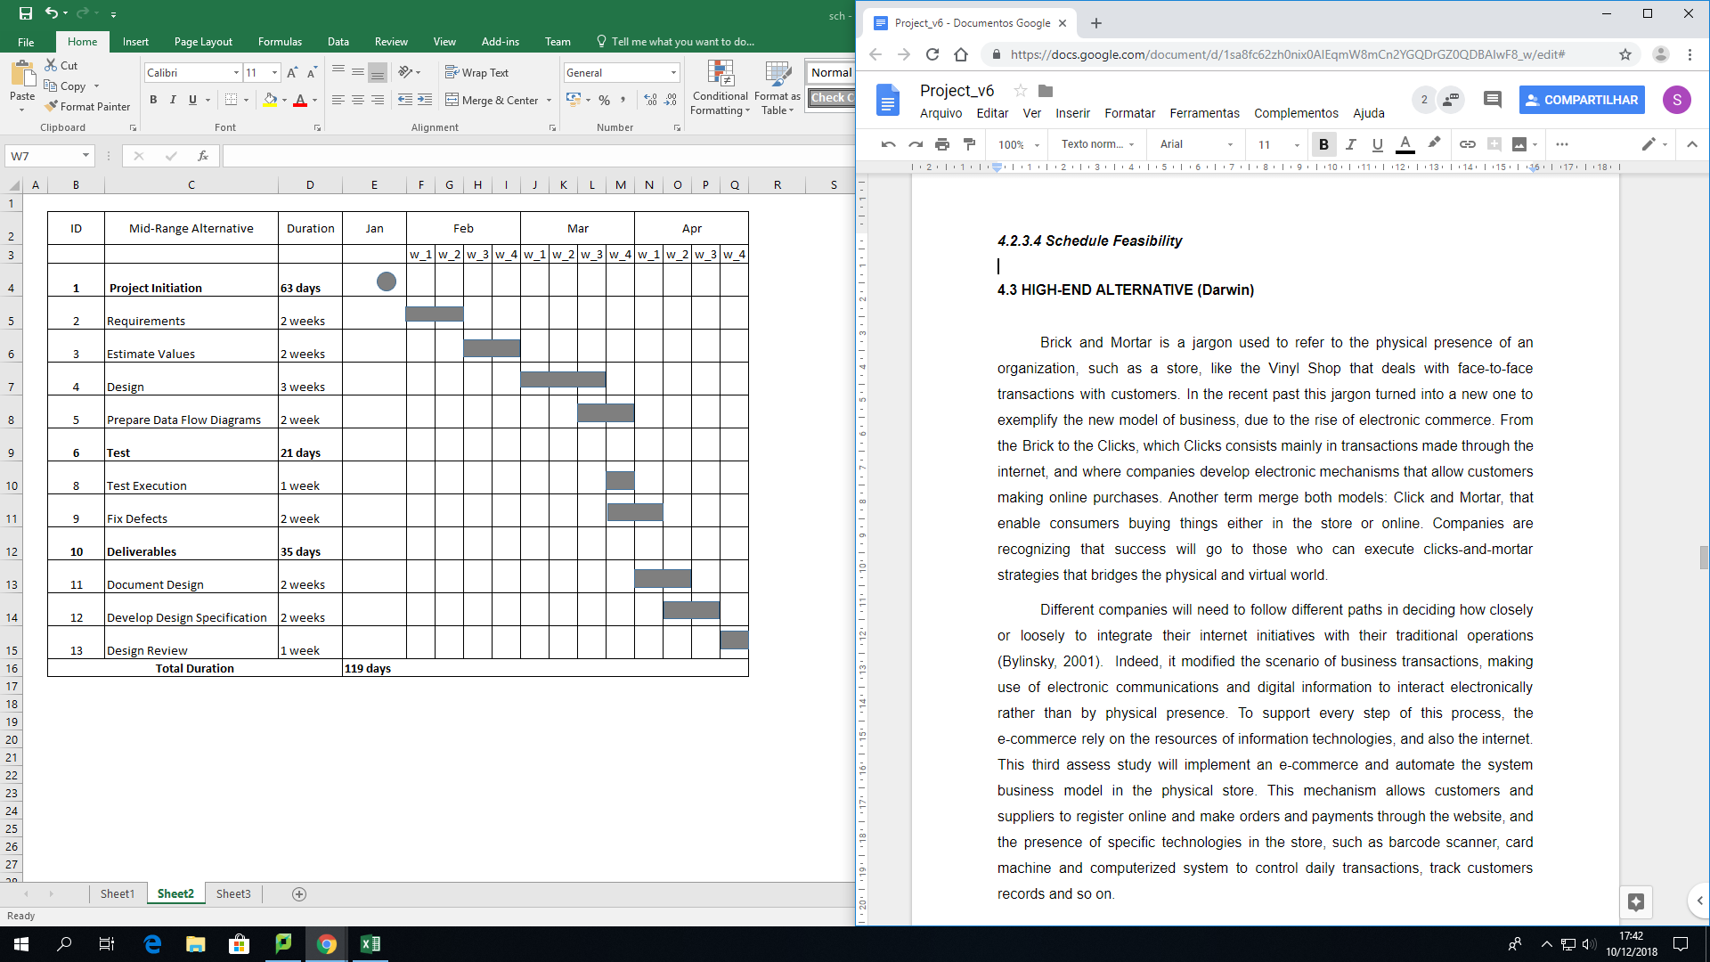

## 

## **4.3 HIGH-END ALTERNATIVE (Darwin)**

Brick and Mortar is a jargon used to refer to the physical presence of an organization, such as a store, like the Vinyl Shop that deals with face-to-face transactions with customers. In the recent past this jargon turned into a new one to exemplify the new model of business, due to the rise of electronic commerce. From the Brick to the Clicks, which Clicks consists mainly in transactions made through the internet, and where companies develop electronic mechanisms that allow customers making online purchases. Another term merge both models: Click and Mortar, that enable consumers buying things either in the store or online. Companies are recognizing that success will go to those who can execute clicks-and-mortar strategies that bridges the physical and virtual world.

Different companies will need to follow different paths in deciding how closely or loosely to integrate their internet initiatives with their traditional operations (Bylinsky, 2001). Indeed, it modified the scenario of business transactions, making use of electronic communications and digital information to interact electronically rather than by physical presence. To support every step of this process, the e-commerce rely on the resources of information technologies, and also the internet. This third assess study will implement an e-commerce and automate the system business model in the physical store. This mechanism allows customers and suppliers to register online and make orders and payments through the website, and the presence of specific technologies in the store, such as barcode scanner, card machine and computerized system to control daily transactions, track customers records and so on.

### **4.3.1 Assumptions and Constraints (Darwin)**

The new system requires specific devices, hardware and internet connection in order to run smoothly. Considering all the changes, initially is necessary to install a base computer with limited configuration, in this case an electronic point of sale, the main purpose of the computer is exclusively perform daily transactions, also the computer must be connected to the internet, and thus it updates the inventory system which is shared between the physical system and online system.

The system will be installed in this computer and used to register products, perform transactions such as update inventory system, process payments and produce sales report. New products should be scanned and registered properly with name, description, product identification, and also an electronic device that can read and output printed barcodes to a computer must be installed, in this case a barcode reader. Besides that, a card machine is made necessary, once the system offers the possibility to customer to pay in cash or by card.

The physical system developed to the company might cover all the desired features pre-established by the owner. Otherwise, the system available online might not present uniqueness to all functionalities desired. Considering that the online store will be purchased by a third part. Due to the level of complexity of the application, the website might not be managed by the owner or any staff, then the maintenance and support must be made by the company hired to bring up the website to live. So that implies the system has legal and contractual restrictions, and it cannot be modified legally by the customer.

Currently the Vintage store has not acquired any software to the company, and the transactions are performed manually, due this situation the software implementation will affect the routine, and the changeover must be made in phases with the current system, considering that each phase will represent part of the system being implemented. Initially, the system will be implemented only in the physical store, and then when the company inventory is up to date the online website will come along.

### **4.3.2 Analysis and Methodology (Darwin)**

This third assess will be based on a tailored made web system fully developed to support all the transactions made online, and sustain the requirements established by the Vinyl Shop. The physical system will be integrated with the online system to keep track of the inventory. The Software designed provides a link between requirements and an implementable specification. In order to illustrate the business concept a use case is used to demonstrate the actors and the transactions performed in the online system. The system designed in object-oriented environment is also included below to show how the system architecture was planned.

#### **4.3.2.1.2 Object- Oriented Data Model Design**

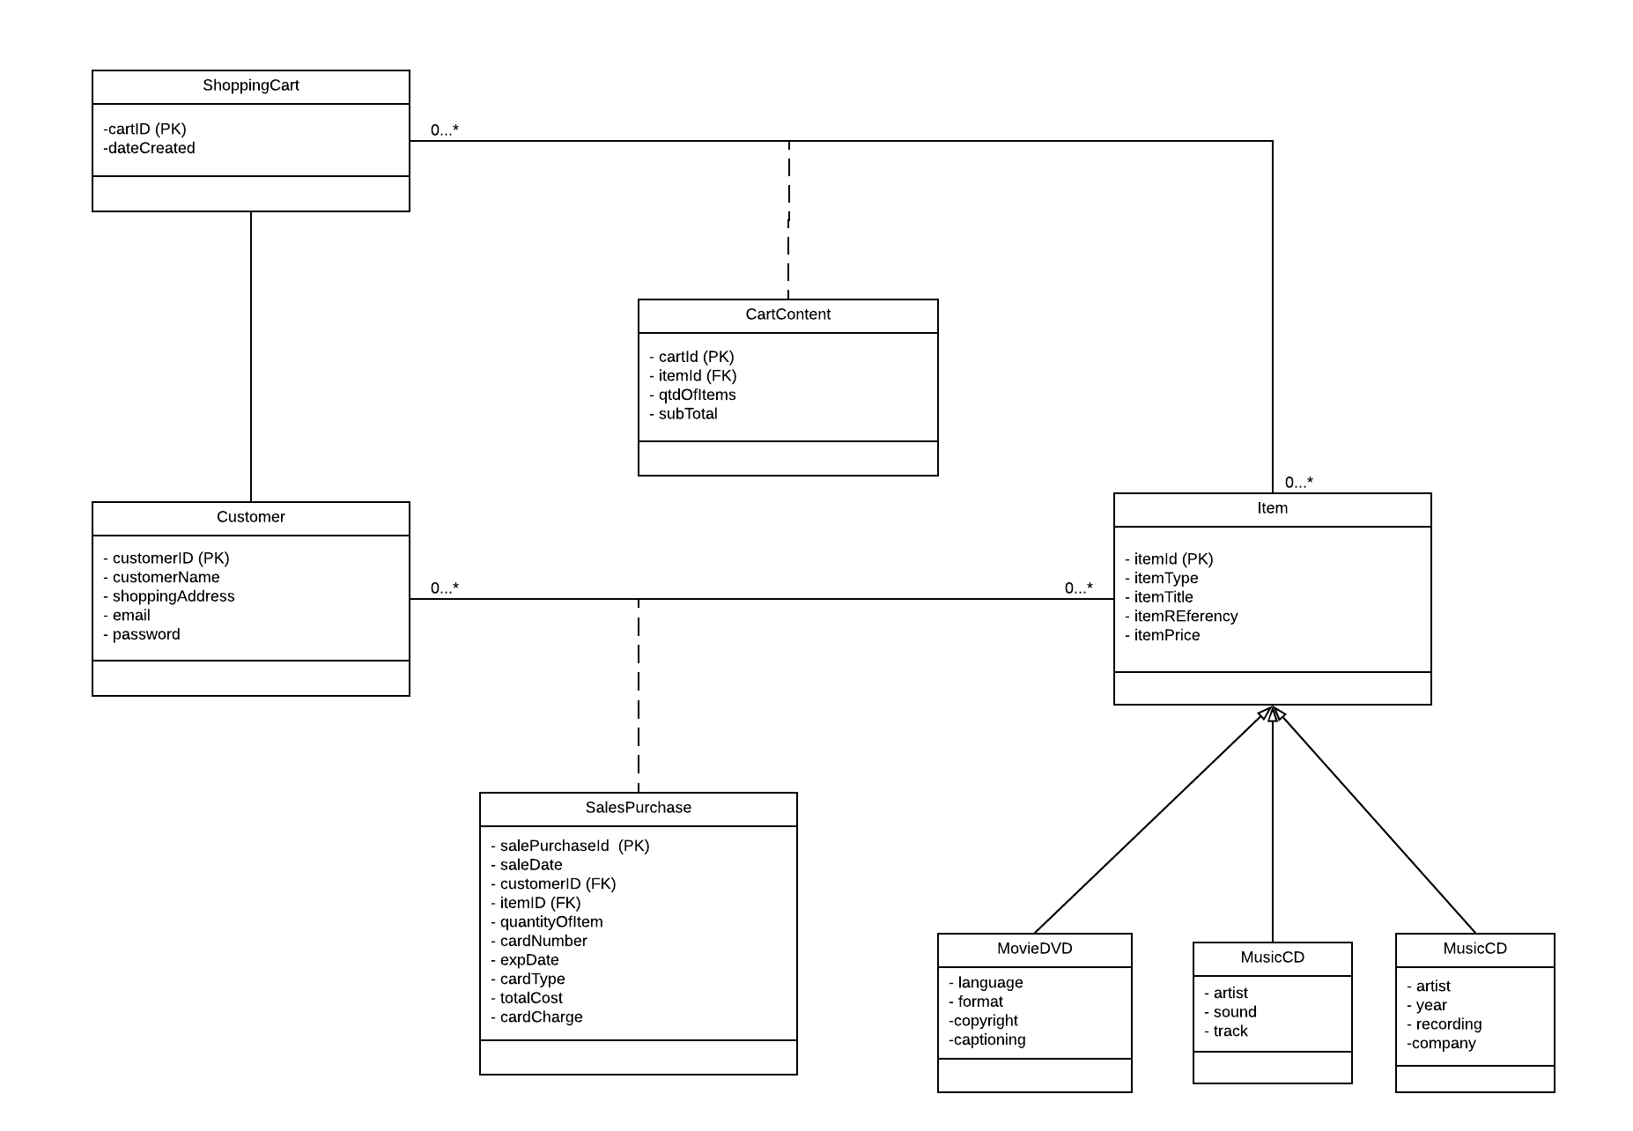

#### **4.3.2.2.1 Use case diagram– Online Store**

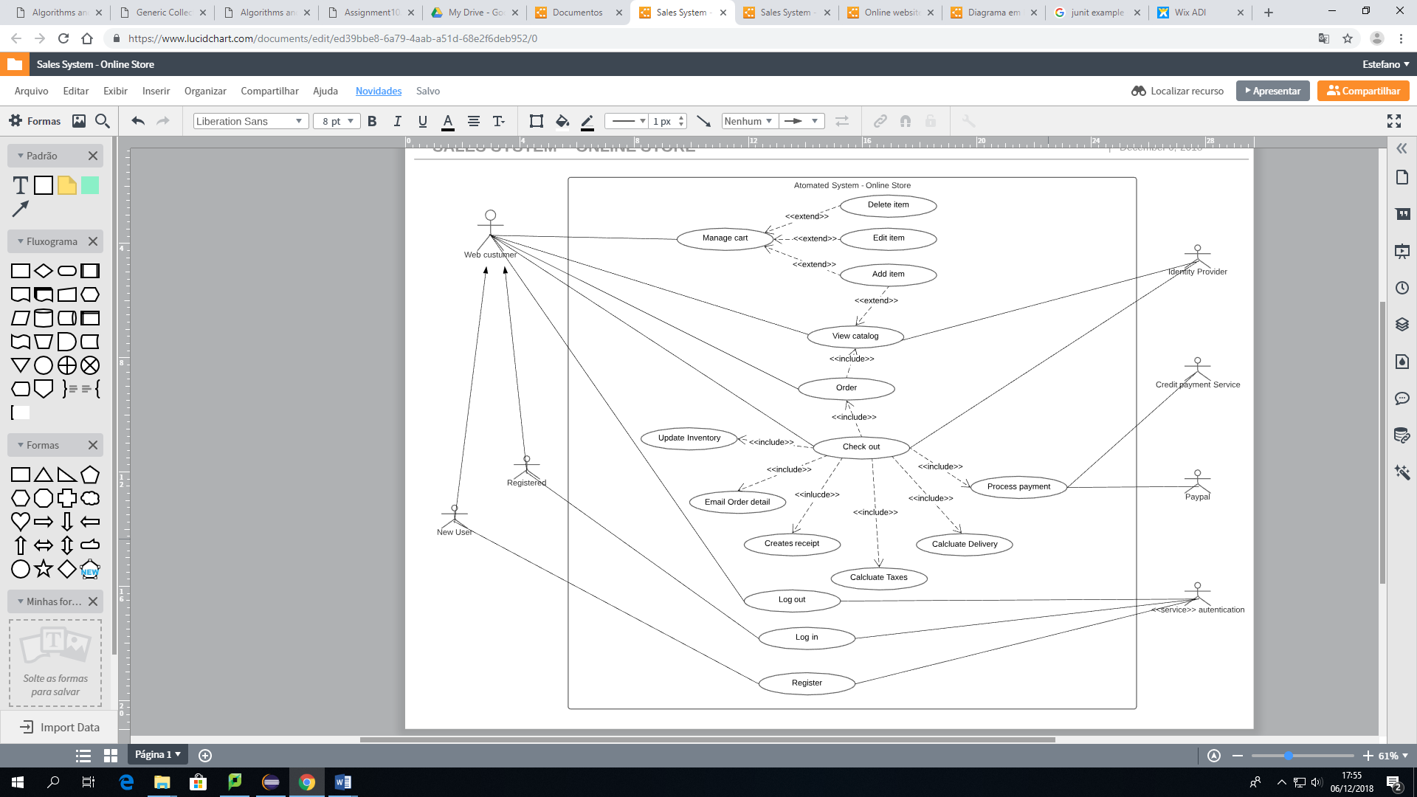

### **4.3.3 Feasibility Study**

#### **4.3.3.1 Technical Feasibility (Darwin)**

This third assessment will focus on a tailored system for The Vintage Shop integrating a physical commerce system installed in the store and an e-commerce to deal with transactions made online. The proposed bespoke software requires an order management to deal with those transactions keeping track of the stock rotation, literally it works as a traffic control for all commerce activities, managing order coming in from across both channels and uses automated business logic to match them with the best fulfilment options to meet customers’ expectations and your profitability goals.

Firstly, the online store must choose the best way of hosting the website. The web host is the company that provides the server and store spaces to website, it is the place where all the HTML files, database, and image files that make up the entire content of the website are stored. For this reason, a cloud hosting would be meet the business needs, keeping a lower cost, rather than a dedicated or shared hosting, which implies in higher cost of investment. Second, the owner must register a domain name, which helps people to find and remembers about the company’s website.

To provide to the store a high customization the site-build method chosen was develop it from scratch, it is an worthwhile endeavour that gives to developers a huge understanding of web editing and design, bringing to the site uniqueness and attractive appeal. The website will be developed using the most popular technologies to build a website, such as HTML (Hyper Text Markup Language) and CSS (Cascading Style Sheets). Likewise, JavaScript will be embedded to the system to add more functionality. The online store has a dependency on database system, which used to store information, such as products, customers, orders, payment details, shipment details and so on. Technologies such as PHP and MySQL are used to perform the communication between the frontend and the database management system (DBMS).

The website must offer to customers a payment gateway and also a credit card processor option, as a second alternative. In order to perform this task is necessary secure the checkout process on the website, also it must provide a privacy policy and a return policy, besides figure out shipping and deliveries methods. Products will still be stored in the physical presence of the business, which allow the owner to control the inventory, and handle with shipment process. Owner or staff are responsible for accessing the database to check customer information for deliveries.

Security is absolutely the most important aspect of a web store. Therefore the site must be securely over customer’s transactions. Thus to ensure it, the connection must be protected, it can be made installing a secured security layer (SSL), which establish an encrypted link between a web server and a web browser.

#### **4.3.3.2 Operational Feasibility (Sarah)**

As mentioned on topics 4.1.3.2 and 4.2.3.2 about the first (Low end) and the second (Mid end) alternatives respectively, the benefits of the third proposal are as the same as the others. By implementing a computerized system in The Vinyl Shop the speed of information exchange and actions within the store will be increased, it also increases the reliability and accuracy of the information kept about customers and products. Also, it is important to take into consideration the data security.

The third proposal adds to The Vinyl Shop, not only the website with a catalog containing pictures and description of the products where customers can browse through the products and make purchase of any item of their choice and have it sent to their homes, but more specifically, this proposal will increase the visibility of the business and reach customers within long distance from the physical store which makes it hard to obtain the desired product.

The importance of a web shop nowadays is due to the fact that some customers prefer the practicality of having such product drove to them instead of spending some time going to a shop when they can have it delivered at their door. Such time could be invested in other activities such as work out, cooking, etc. Thus, the customer’s habits and hobbies will not be affected by their desire to purchase any item.

Once more there will be the need of training the staff and the owner of The Vintage Shop in order to maintain the good behaviour of the EPoS system. In this case, instead of hiring a freelance web designer, it is recommend hiring an IT professional who is able to maintain either the physical system or the web store by updating its information. Therefore, the support and maintenance will be more accurate once it will be made by a specialist.

#### **4.3.3.3 Economic Feasibility (Paula)**

The third assessment will be similar to the mid-range one, but it will comprise some changes in the website proposal, which will no longer be a catalog but a online store instead. For that, the freelancer hired will develop an eCommerce website to allow the customers to make orders, purchases and there will also be a space for giving feedback after finishing shopping. The webmaster is also hired for this software, having the same responsibilities as in the mid-range alternative, being responsible for the maintenance of the webstore, updating products, prices, and offers when necessary. The tangible costs for the proposal of a computerized physical system integrated with a website and webstore are described in the table below, discerning between development and operational costs.

| **Type of cost** | **Phase** | **Item/Service** | **Cost (average)** |
| --- | --- | --- | --- |
| **Tangible** | **Development** | Scanner (barcode-reader) | € 52.31 |
| EPOS bundle + software | € 1,338.00 |
| Training | € 367.31 |
| eCommerce Website cost (one-off) | € 2,300.00 |
| **Total development costs** | **€ 4,057.61** |
| **Operating** | Broadband (240 Mb - monthly) | € 38.17 |
| Rolls for receipt printer | € 1.00 |
| Rolls for card machine | € - |
| Hosting + Domain (monthly) | € 8.17 |
| Webmaster (4h to 10h monthly) | € 200.00 |
| **Total operating costs** | **€ 247.33** |
| **Total tangible costs** | | **€ 4,304.94** |

The high-end alternative brings, in addition to all the benefits already listed, the possibility to acquire products 24/7 once online stores do not stop working - even if it is midnight or a holiday the customers will be able to make their purchases or even get some discounts in special dates. Also, as already mentioned, with the introduction of an online store a channel for customers feedback will be open, so they can share their experience with the online shopping method for this store, helping the owner together with the webmaster to decide whether and/or how it is better change to better meet the customer needs. All the benefits provided by this software are shown in the table below.

| **Benefits** | |
| --- | --- |
| **Tangible** | **Intangible** |
| Fewer processing errors | Improved customer service |
| Increased throughput |
| Decrease time of each operation | Better decision making |
| Increase sales | Increase credibility |
| Reduced expenses |
| Reduced data losses | Improved employee morale |
| Increase customers |
| Wider products advertise | Customer satisfactions |
| Accessibility to products 24/7 |

#### **4.3.3.4 Scheduling Feasibility (Aline)**

The High-Range alternative is the most complex Scheduling Feasibility, as it should be expected, considering that this Software Proposal is specifically tailored for the the Vinyl Shop. Not only there’s a software to be installed in the tills, but the website of the shop has the purpose of advertising, informing, and online selling.

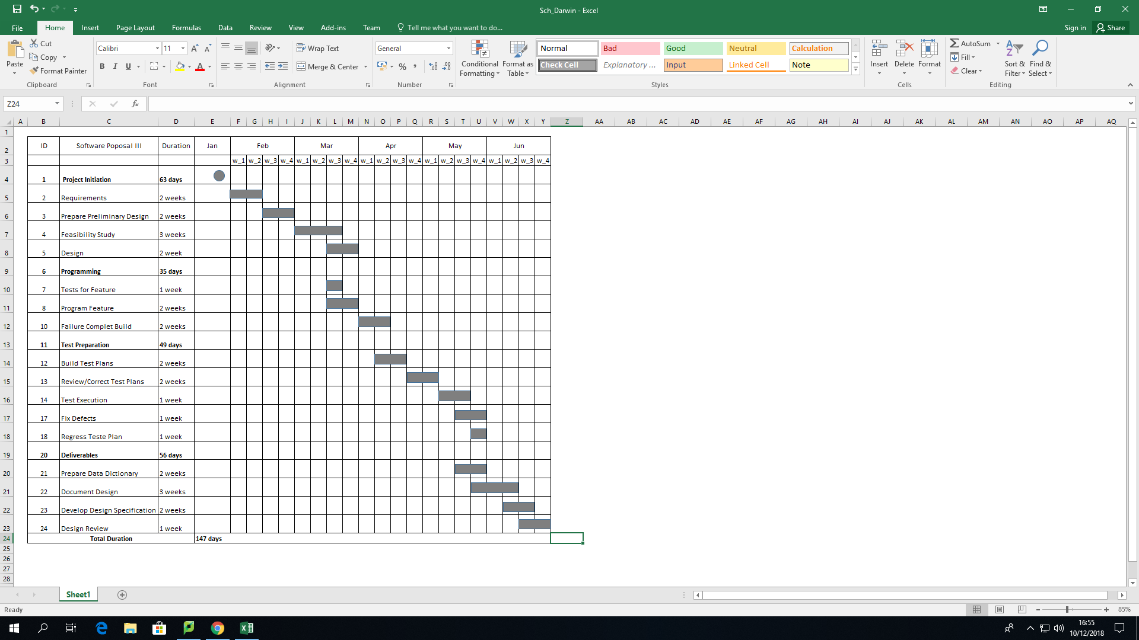

# 5. RECOMMENDATION (Aline & Paula)

Based on the findings and relevant information presented in this feasibility study, it is highly recommended that one of the Proposed Softwares is chosen by the owner of the shop. It is a consensus that the choice will be based not only on the comprehensiveness of the proposal, but also considering the available budget to the project implementation.

A change in the way that the business of the shop is conducted, is mandatory in order to insert the shop in the contemporaneous system adopted by different businesses. The study clearly shows how beneficial the implementation of one of the proposals would be, once it would save time, increase security, optimize the search of information, promote online presence and minimize the possibility of human error.

A resume of the three Proposed Softwares is presented below:

| **Criteria** | **Weight** | **Alt A: Computerized system** | | **Alt B: Computerized system + website** | | **Alt C: Computerized system + website + online shop** | |
| --- | --- | --- | --- | --- | --- | --- | --- |
| **Requirements** | **Rating** | **Score** | **Rating** | **Score** | **Rating** | **Score** |
|
| Computerized system | 25 | 5 | 125 | 5 | 125 | 5 | 125 |
| Online presence | 10 | 0 | 0 | 4 | 40 | 5 | 50 |
| Electronic ordering | 10 | 0 | 0 | 0 | 0 | 5 | 50 |
| Payment transactions | 10 | 3 | 30 | 3 | 30 | 4 | 40 |
| **Total requirements** | **55** |  | **155** |  | **195** |  | **265** |
|  |  |  |  |  |  |  |  |
| **Constraints** |  |  |  |  |  |  |  |
| Limited investment budget | 25 | 5 | 125 | 3 | 75 | 2 | 50 |
| Physical delivery mechanism | 5 | 2 | 10 | 2 | 10 | 2 | 10 |
| Small staff | 15 | 5 | 75 | 2 | 30 | 2 | 30 |
| **Total constraints** | **45** |  | 365 |  | **310** |  | **355** |
|  |  |  |  |  |  |  |  |
| **Total** | **100** |  | **520** |  | **505** |  | **620** |

# 6. FINAL CONSIDERATIONS (Aline)

A feasibility study is essential in order to define the chances of completing successfully a project regardless the budget, size or location of the business. This project was directed to a small shop that sells second hand items, aiming to determine the possible positive and negative outcomes of a project before investing time and money on it.

Some relevant aspects were considered in each one of the Proposed Softwares, such as: technical feasibility, operational feasibility, economic feasibility and schedule feasibility. In order to provide to the business owner all the needed information, supporting the decision that will be made.

It is believed that the main topics were approached in a concise way contributing to form a clear idea of what to expect from the proposals above reported. The final decision about which one is more adequate to the shop is concerned to the owner, who will balance the relevance, goals and available budget and time to be invested in the revitalization of the business.

# 7. BIBLIOGRAPHY

Bylinsky, G. 2001 “The e-Factory Catch On”. Fortune.

Bordonaba‐Juste, V., Lucia‐Palacios, L. and Polo‐Redondo, Y. (2012). Antecedents and consequences of e‐business adoption for European retailers. *Internet Research*, 22(**5**), pp.532-550.

Janita, I. and Chong, W. (2013). Barriers of B2B e-Business Adoption in Indonesian SMEs: A Literature Analysis. *Procedia Computer Science*, 17, pp.571-578.

Malaga, R. A. (2005). *Information systems technology*. Upper Saddle River, NJ: Pearson Prentice Hall.

Marakas, G.M. and O'Brien, J.A., (2013). *Introduction to information systems*. 16th edn. McGraw-Hill, Inc., New York.

Van Teijlingen, E. and Hundley, V. (2001). The importance of pilot studies. *Social research Update*, 16(**35**), pp.33-36.

# APPENDICES

1. **Website Design** 
   1. **Home page**

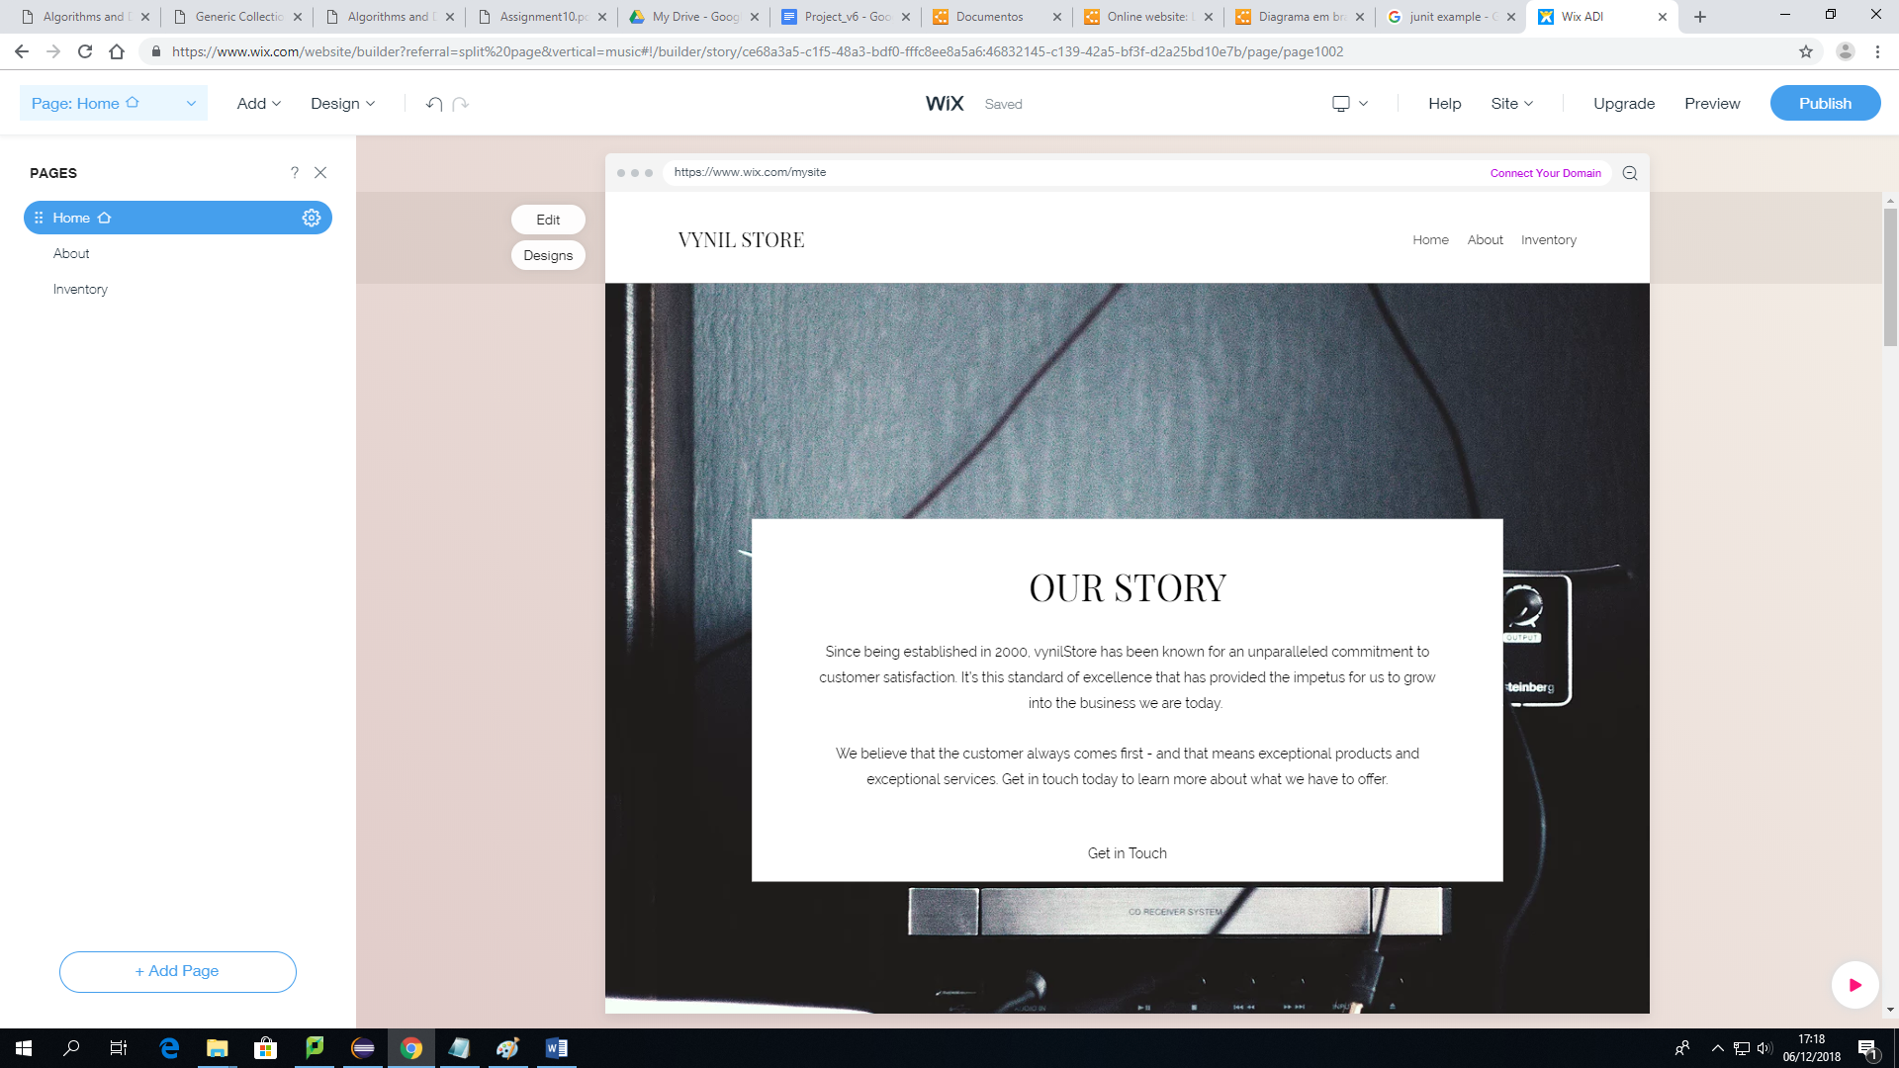

* 1. **Products**

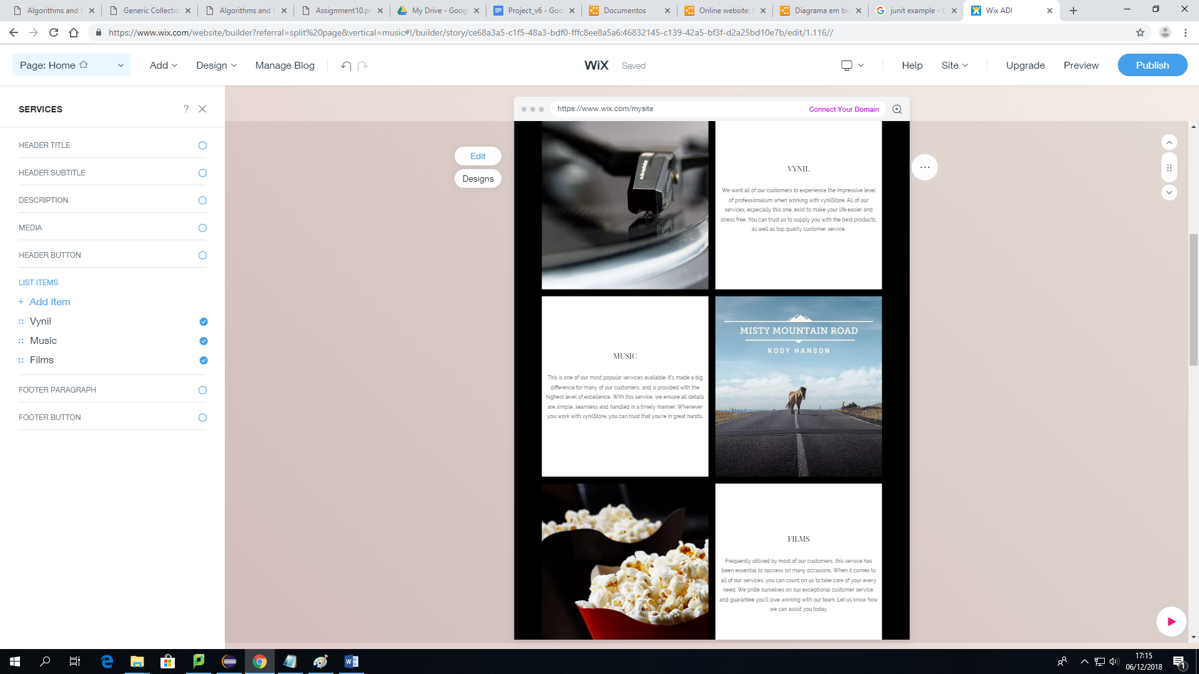

* 1. **Get in touch**

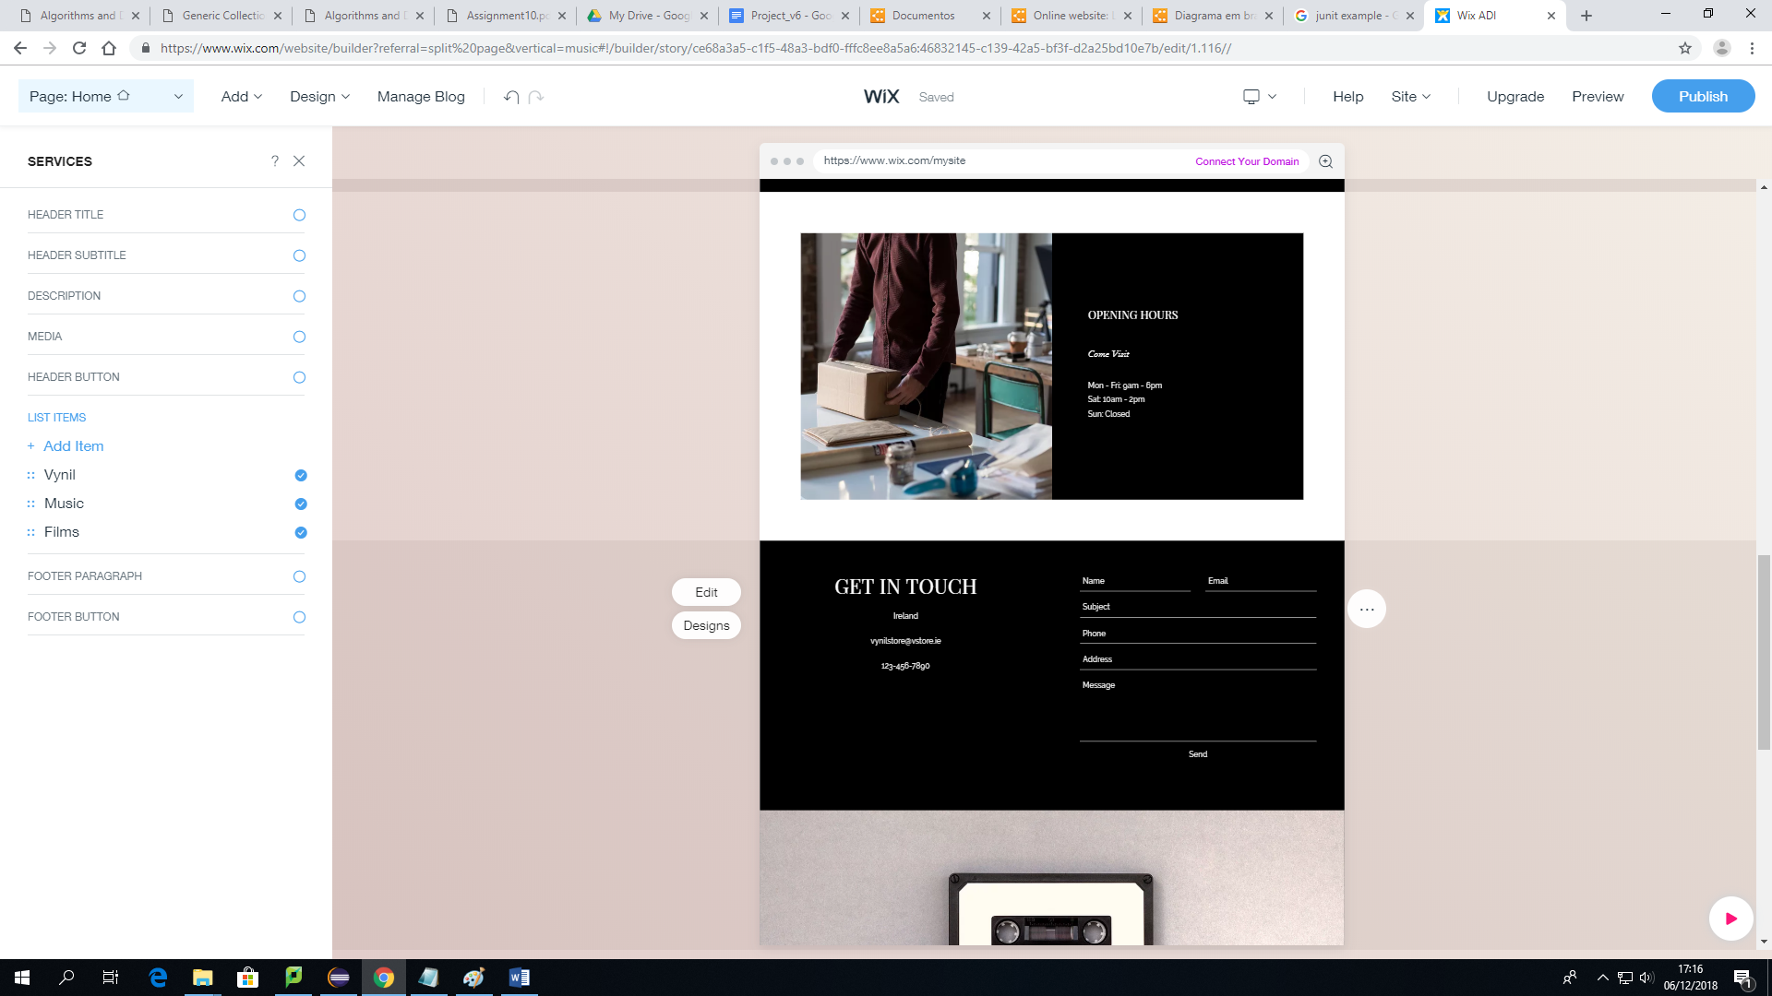

1. **Online Shop**
   1. **Home page**

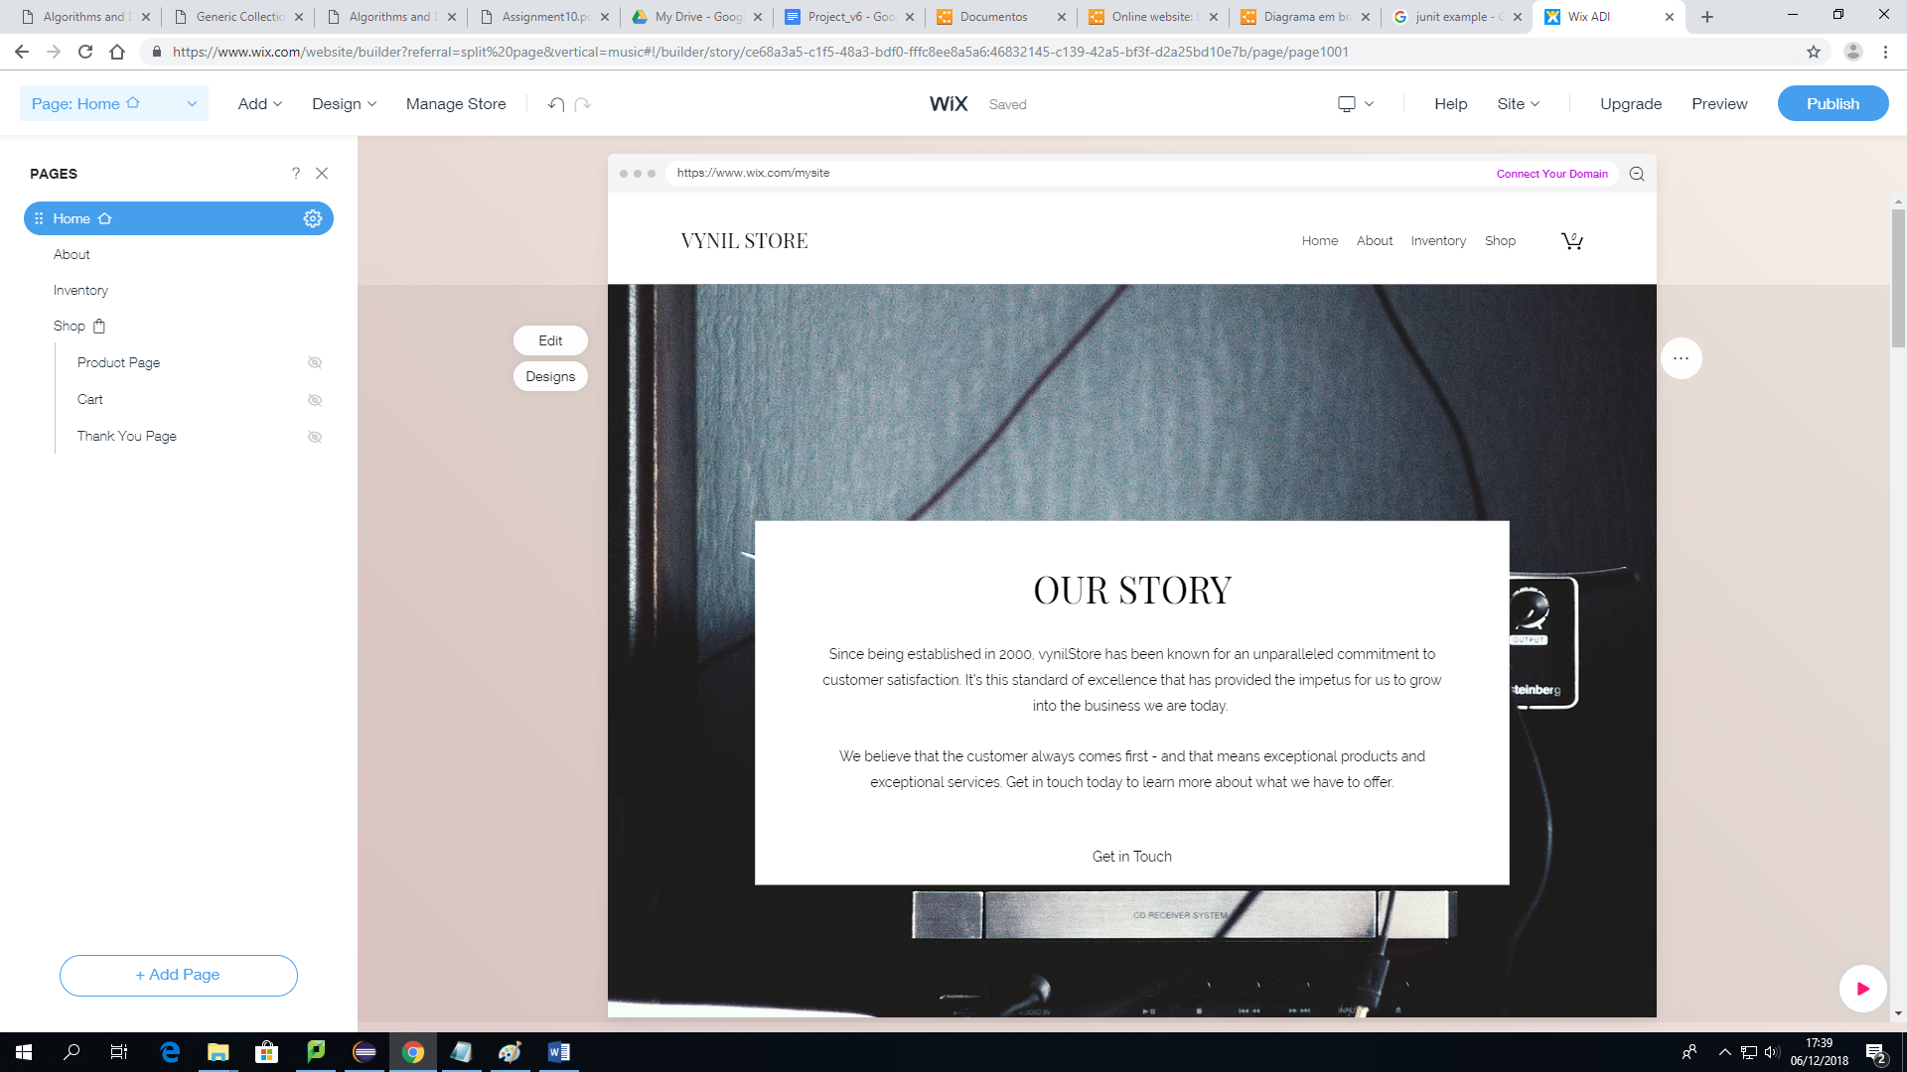

**III. Sources for the low-cost alternative**

| **Physical Store Only** | | | | | |
| --- | --- | --- | --- | --- | --- |
| **Quantity** | **Item/Service** | **Source 01** | **Source 02** | **Source 03** | **Mean** |
| 1 | Scanner (barcode-reader) | € 47.44 | € 56.59 | € 52.89 | € 52.31 |
| 1 | EPOS bundle + software | € 1,338.00 | - | - | - |
| 1 | EPOS bundle + card machine + EPOS software + iPad | - | € 1,148.74 | - | - |
| 1 | EPOS bundle + card machine + EPOS software + Samsung Galaxy tablet | - | - | € 1,196.28 | - |
| - | Broadband (240 Mb - monthly) | € 35.00 | € 46.50 | € 33.00 | € 38.17 |
| - | Training | € 367.31 | € 367.31 | € 367.31 | € 367.31 |
| **Total** | | **€ 1,787.75** | **€ 1,619.14** | **€ 1,649.48** | **€ 1,685.45** |

**IV. Sources for the mid-range alternative**

| **Physical Store + Website** | | | | | |
| --- | --- | --- | --- | --- | --- |
| **Quantity** | **Item/Service** | **Source 01** | **Source 02** | **Source 03** | **Mean** |
| 1 | Scanner (barcode-reader) | € 47.44 | € 56.59 | € 52.89 | € 52.31 |
| 1 | EPOS bundle + software | € 1,338.00 | - | - | - |
| 1 | EPOS bundle + card machine + EPOS software + iPad | - | € 1,148.74 | - | - |
| 1 | EPOS bundle + card machine + EPOS software + Samsung Galaxy tablet | - | - | € 1,196.28 | - |
| - | Broadband (240 Mb - monthly) | € 35.00 | € 46.50 | € 33.00 | € 38.17 |
| - | Training | € 367.31 | € 367.31 | € 367.31 | € 367.31 |
| - | Website development cost (one-off) | € 1,400.00 | € 1,500.00 | € 1,450.00 | € 1,450.00 |
| - | WordPress Premium (monthly) | € 8.00 | € 8.00 | € 8.00 | € 8.00 |
| - | WordPress self-hosting (monthly) | € 8.96 | € 8.96 | € 8.96 | € 8.96 |
| - | Hosting + Domain (monthly) | € 8.00 | € 8.33 | € 8.33 | € 8.17 |
| - | Webmaster (monthly - 2h to 5h monthly) | € 100.00 | € 100.00 | € 100.00 | € 100.00 |
| **Total** | | **€ 3,312.71** | **€ 3,244.44** | **€ 3,224.78** | **€ 3,260.58** |

**V. Sources for the high-end alternative**

| **Physical Store + Website + Online Store** | | | | | |
| --- | --- | --- | --- | --- | --- |
| **Quantity** | **Item/Service** | **Source 01** | **Source 02** | **Source 03** | **Mean** |
| 1 | Scanner (barcode-reader) | € 47.44 | € 56.59 | € 52.89 | € 52.31 |
| 1 | EPOS bundle + software | € 1,338.00 | - | - | - |
| 1 | EPOS bundle + card machine + EPOS software + iPad | - | € 1,148.74 | - | - |
| 1 | EPOS bundle + card machine + EPOS software + Samsung Galaxy tablet | - | - | € 1,196.28 | - |
| - | Broadband (240 Mb - monthly) | € 35.00 | € 46.50 | € 33.00 | € 38.17 |
| - | Training | € 367.31 | € 367.31 | € 367.31 | € 367.31 |
| - | Website development cost (one-off) | - | € 1,450.00 | € 1,450.00 | € 1,450.00 |
|  | eCommerce platform (monthly) | - | € 69.41 | € 70.24 | € 69.83 |
| - | eCommerce Website cost (one-off) | € 2,300.00 | - | - | - |
| - | Hosting + Domain (monthly) | € 8.00 | € 8.33 | € 8.33 | € 8.17 |
| - | Webmaster (monthly - 4h to 10h monthly) | € 200.00 | € 200.00 | € 200.00 | € 200.00 |
| **Total** | | **€ 4,295.75** | **€ 3,346.88** | **€ 3,378.05** | **€ 3,673.50** |

**INDIVIDUAL EVALUATION AND COMMENTS**

**Meeting 1**

Date: 05/11/2018 (from 11am to 1pm)

Participants: Aline Fernandes, Amandio Pinto, Darwin Stefano, Paula Oehme and Sarah Narayamy.

Activities: The main topics to be discussed and the architecture of the project were decided.

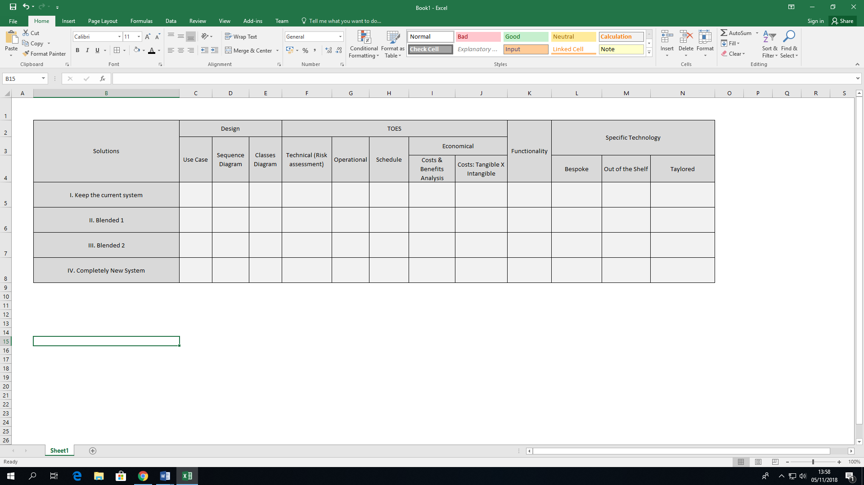

**Meeting 2**

Date: 05/11/2018 (from 2pm to 5pm)

Participants: Aline Fernandes, Amandio Pinto, Darwin Stefano, Paula Oehme and Sarah Narayamy.

Activities: Definition and description of the Summary of the project and template of the presentation.

**Meeting 3**

Date: 06/11/2018 (from 10am to 5pm)

Participants: Aline Fernandes, Amandio Pinto, Darwin Stefano, Paula Oehme and Sarah Narayamy.

Activities: The group started working on the project, researching and writing the initial topics.

**Meeting 4**

Date: 06/11/2018 (from 2pm to 5pm)

Participants: Aline Fernandes, Amandio Pinto, Darwin Stefano, Paula Oehme and Sarah Narayamy.

Activities: The group kept working on the project, researching and writing the topics.

**Meeting 5**

Date: 07/11/2018 (from 10am to 2pm)

Participants: Aline Fernandes, Amandio Pinto, Darwin Stefano, Paula Oehme and Sarah Narayamy.

Activities: The group kept working on the project, researching and writing the topics.

**Meeting 6**

Date: 07/11/2018 (from 2pm to 5pm)

Participants: Aline Fernandes, Amandio Pinto, Darwin Stefano, Paula Oehme and Sarah Narayamy.

Activities: The group kept working on the project, researching and writing the topics.

**Meeting 7**

Date: 20/11/2018 (from 5pm to 6pm)

Participants: Aline Fernandes, Paula Oehme and Sarah Narayamy.

Activities:

**Meeting 8**

Date: 27/11/2018 (from 2pm to 3pm)

Participants: Aline Fernandes, Amandio Pinto, Darwin Stefano, Paula Oehme, Sarah Narayamy and Sonia Zheleva.

Activities: A few topics were changed, such as the DataBase Model Diagram, from where the suppliers were excluded and a few other items included.

**Meeting 9**

Date: 27/11/2018 (from 5pm to 6pm)

Participants: Aline Fernandes, Amandio Pinto, Darwin Stefano, Paula Oehme and Sarah Narayamy.

Activities: The content of the project was completely reviewed, the texts corrections were made and the group started finalizing the presentation.

**Meeting 10**

Date: 10/12/2018 (from 10pm to 1pm)

Participants: Aline Fernandes, Darwin Stefano, Paula Oehme and Sarah Narayamy.

Activities: Presentation was finalized, a few more ideas were exchanged in order of compiling the number of slides and a few values were revised on the tables of Economical Feasibility.

**Meeting 11**

Date: 10/12/2018 (from 5pm to 8pm)

Participants: Aline Fernandes, Darwin Stefano, Paula Oehme and Sarah Narayamy.

Activities: The presentation was discussed, the order of the presenters was established and the final adjustments were made. The group also trained for the presentation.